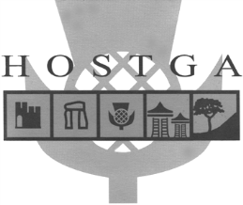
Professional Tour Guides for the
Highlands of Scotland

Dornoch Shops Familiarisation

HOSTGA Guides provide Guiding Services for Cruise Ship Excursions from Invergordon.
HOSTGA has over eighty guides in its membership.
Hello. HOSTGA is contacting you because you have a business in Dornoch. When Cruise Ship Passengers are enjoying an Excursion which includes a stop in Dornoch, the Coaches and Private Hire Transport drive slowly through the town on arrival. The Guides’ commentary includes as much as possible about what shops and attractions are available to see. Most guides do not live in the Dornoch area and therefore maybe do not know the Dornoch shops as well as they might.
HOSTGA is organising a training event to improve its Members’ knowledge of Dornoch facilities and on Friday April 5th will be touring the centre of Dornoch with five minute stops at relevant businesses and organisations.
Do you ever have tourist visitors in your shop? Would you like to have more sales?
Would you like to be included on the itinerary?

Contact Chris Williams 01862 842311 or email chris.williams300@yahoo.co.uk

Friday 5th April 2019

