The Companies Act 2006

____________________________________
Company Limited by Guarantee
and not having a share capital
____________________________________

Memorandum
and
Articles of Association
of
The Dornoch Area Community Interest Company

as amended 16/05/2013

1
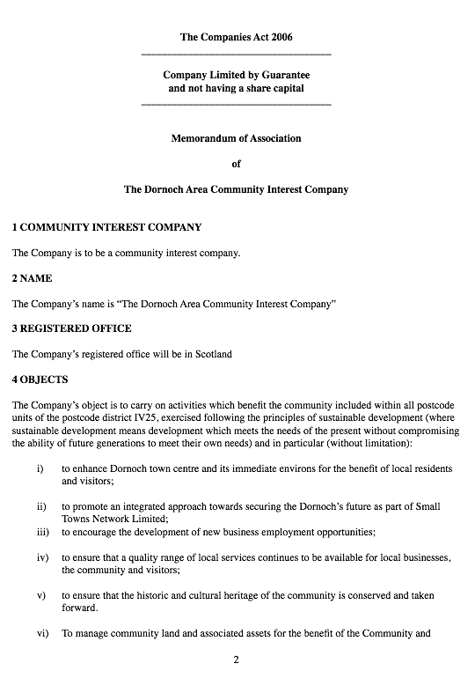
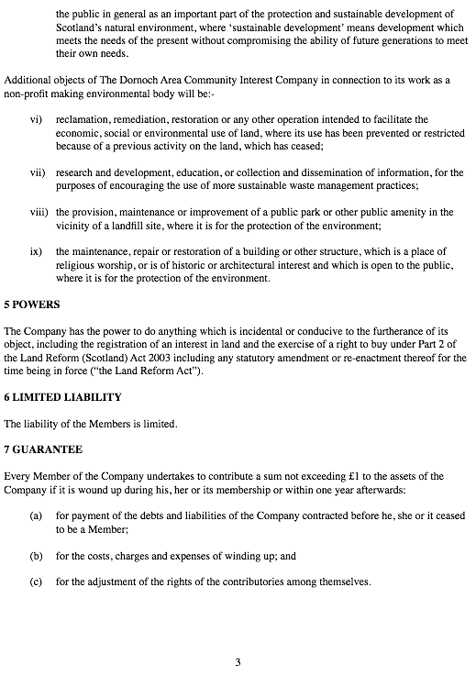

The Companies Act 2006

____________________________________
Company Limited by Guarantee
and not having a share capital
____________________________________

Articles of Association
of
The Dornoch Area Community Interest Company

as amended 16/05/2013

4

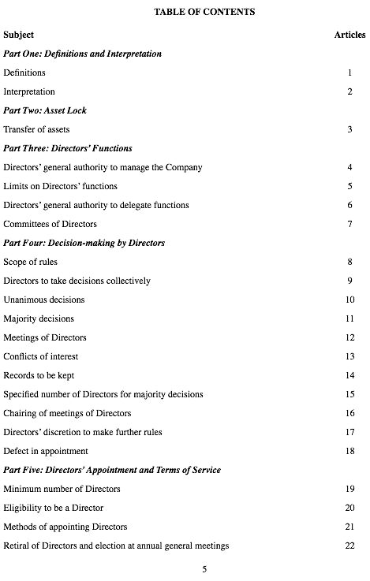
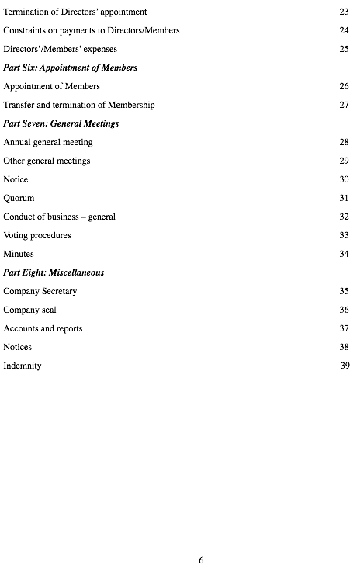

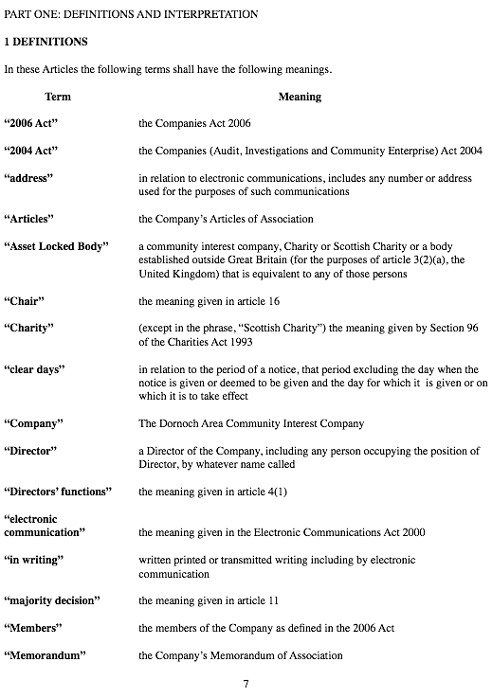

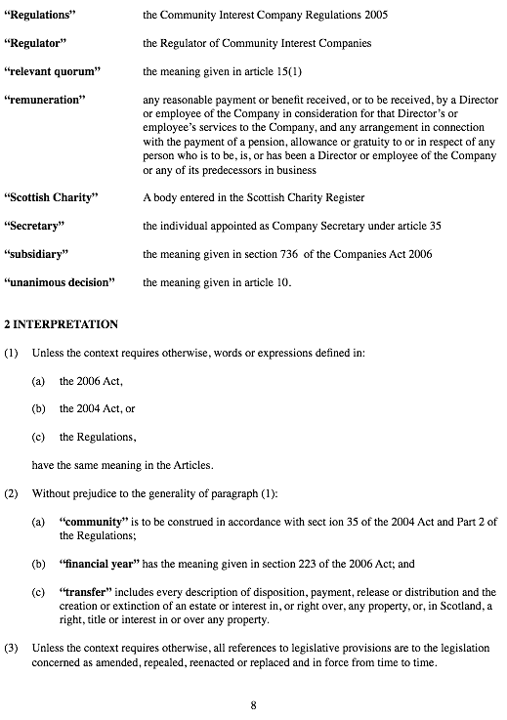
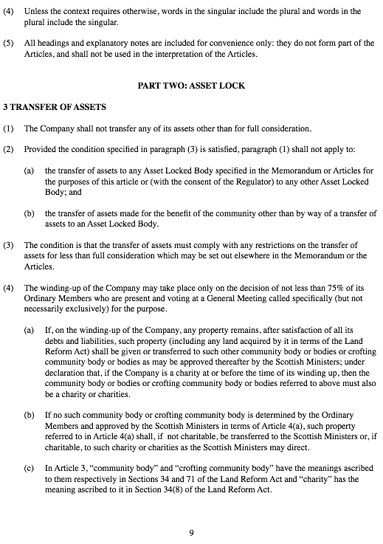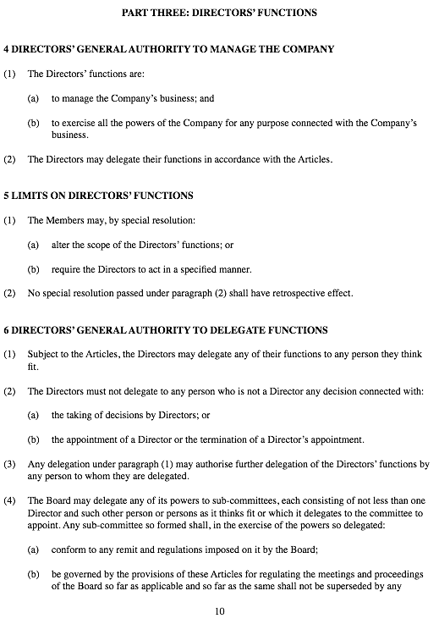

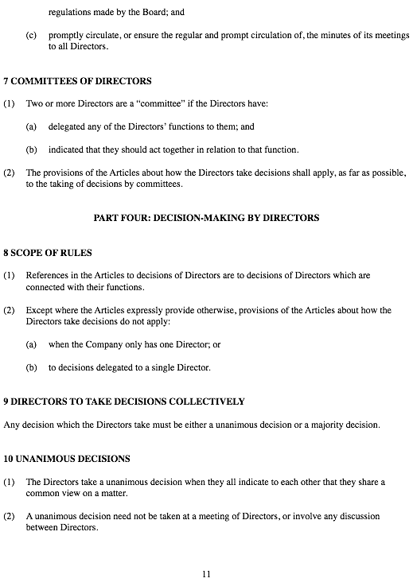

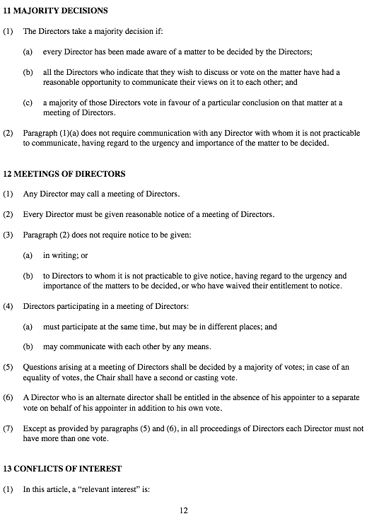

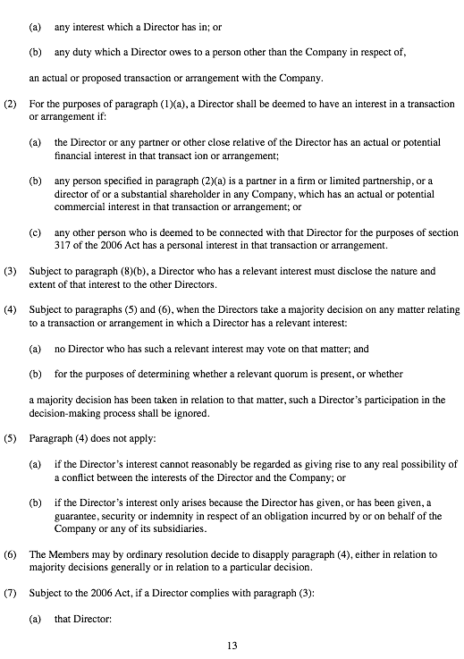

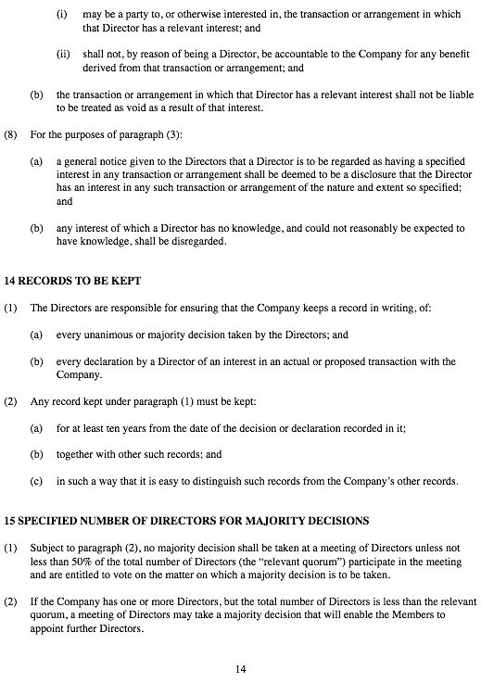

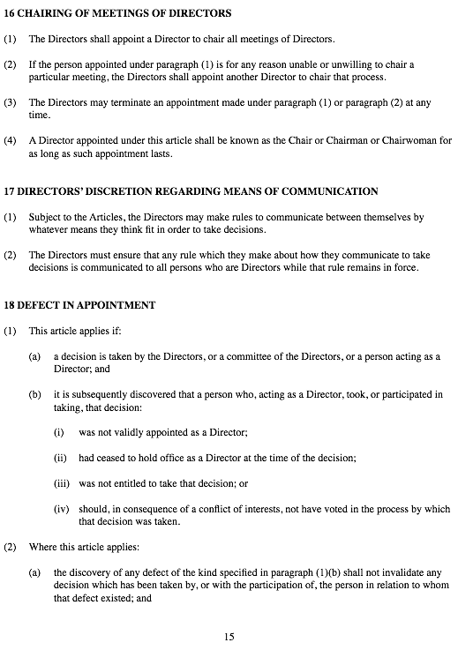

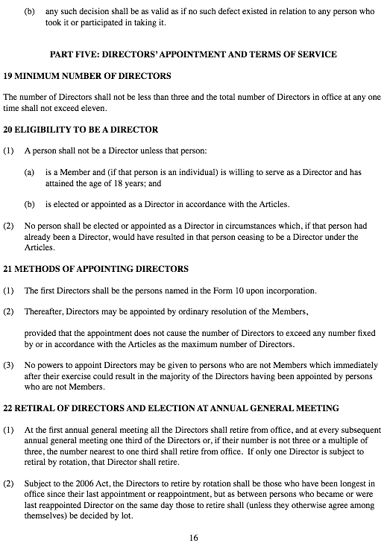
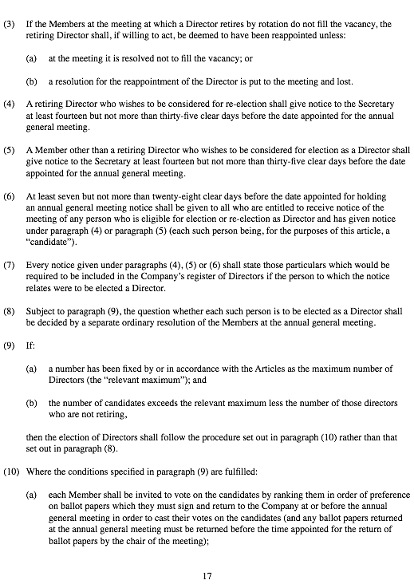

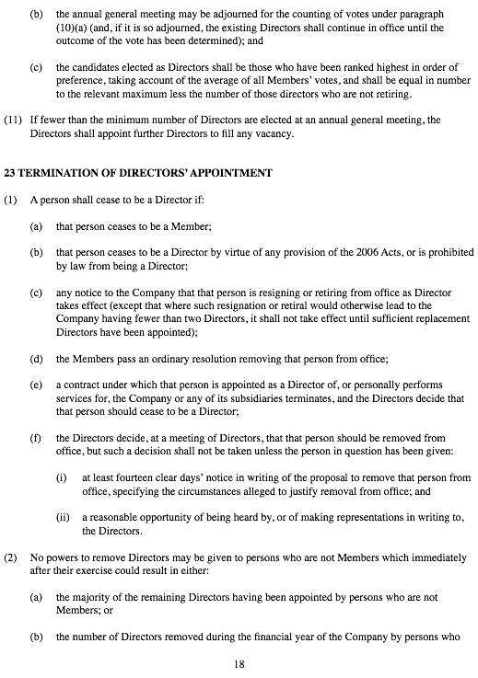
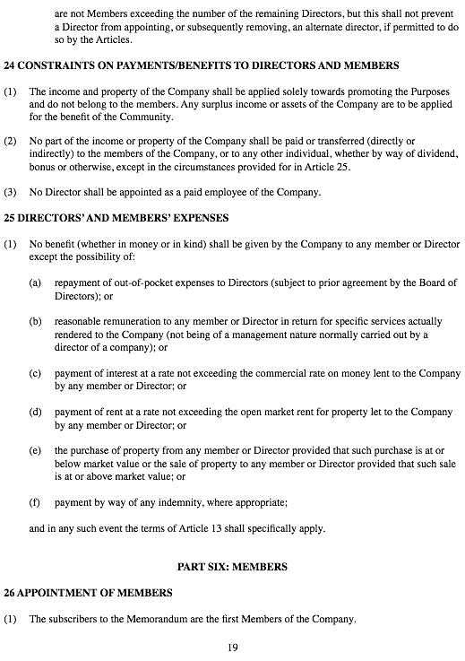

- Such other persons as agree to become Members of the Company, whose names are entered in the register of Members, and who are admitted to membership in accordance with the Articles, shall be members of the Company.

- Membership of the Company is open to those individuals aged 18 and over who:

- are ordinarily resident in the Community; and
(b) are entitled to vote at a local government election in a polling district that includes the Community or part of it; and
(c) who support the objects of the Company.

- The Directors shall approve any valid application for membership

- Every person who wishes to become a Member shall execute and deliver to the Company an application for membership in such form (and containing such information) as the Directors require.

- The Company shall have not fewer than 20 members at any time.

27 TRANSFER AND TERMINATION OF MEMBERSHIP

- Membership is not transferable to anyone else.

(2) Membership is terminated if:
- the Member dies or ceases to exist;

- the Members pass an ordinary resolution expelling the Member; or

- otherwise in accordance with the Articles.

- No resolution shall be passed under paragraph (2) unless the Member has been given:

(a) at least fourteen clear days’ notice in writing that it is proposed to expel him, her or it, specifying the circumstances alleged to justify expulsion; and

- a reasonable opportunity of being heard by or of making written representations to the Members passing the ordinary resolution.

PART SEVEN: GENERAL MEETINGS (MEETINGS OF MEMBERS)

28 ANNUAL GENERAL MEETING

The Company shall hold an annual general meeting:

- within 18 months of the Company’s date of incorporation and afterwards once in each

20



