ENTRY FORM
Entry forms must be emailed to captain@royaldornoch.com or handed into the office by Monday 23rd May midday.
Please print clearly and also sign the disclaimer we need to include.
NAME (Parent or Member displaying) :……………………………………………………………

Junior’s Name: …………………………………… RDGC Section: ………………………………

Adult non-member: ……………………………… or Business: …………………………………..

ADDRESS: ……………………………………………………………………………………………

HOME PHONE: ……………………………………… MOBILE: ………………………………......

EMAIL: …………………………………………………
I agree that the panel judges for this competition may enter my garden at the above address in order to take a photograph of my entry on 1st or 2nd June and they will not be held liable for any damage incurred in doing so.
(If emailing your entry then a printed signature is acceptable)

SIGNATURE:……………………………………………………….. DATE……………………………………
A few examples from 2016 to get you started
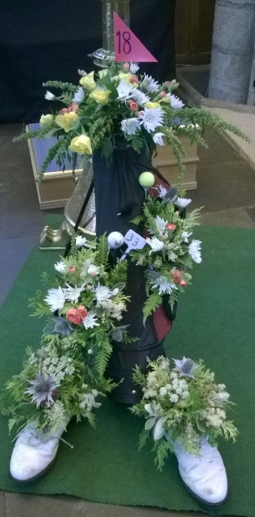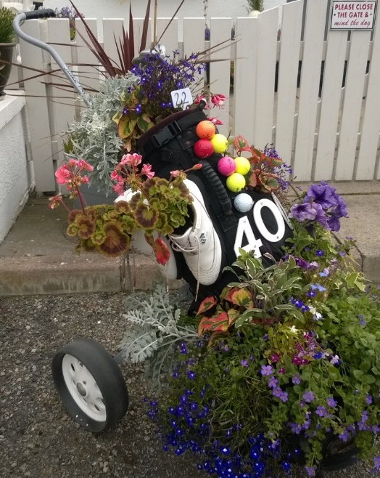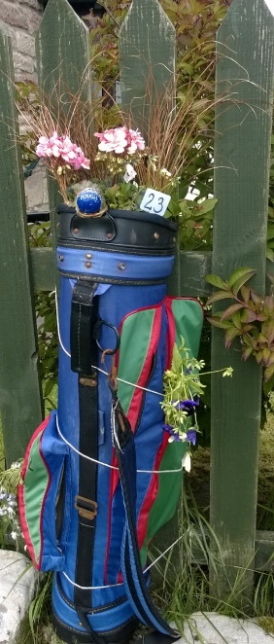
RULES: The rules are very simple:
- Your entry form must be emailed to captain@royaldornoch.com or handed into the golf club office by Monday 23rd May (midday).

- We are aware that the 4th of June is rather early in the season but if your plants are late in developing you will still have a colourful display to view at home.

- The judging panel will view your display at your home. A numbered label will be attached to your display and then a photo taken with the label visible so we can have a record of entries. This will also let you know that your display has been judged.

- Judges will know which section the bag has been entered in. A final decision will be made once all bags have been viewed and the judges opinions finalised.

- Four local sections: (a) Minis & Advanced Minis; (b) Wildcats; (c) B, B+ & A Sections; (d ) Local Adults (members and non-members) and Businesses.

- Away members can email a photo of their display to captain@royaldornoch.com with your name and town included in the email.
Saturday 4th June at Cathedral Green.
Local entries: We would love to display bags on Saturday when Dornoch’s Platinum Jubilee Celebrations are being held with music, children’s activities, tea and home baking, fancy dress competition, stalls, games, etc. Take you bag to Cathedral Green between 11 & 12 and display them on the pavement in front of Trevose.

You can display you decorated golf bag in a golf trolley, wheelbarrow, strap to a lamp post, a baby buggy, in fact anything that makes it safe and small children or dogs don’t knock it over.

Please don’t take your bag to the Cathedral Green before 11am. It must be removed by 6pm, earlier is fine. Make sure that your label is secure and for Saturday, if you wish, please add your name to the label so the public can see whose bag it is. After the Jubilee celebrations enjoy your colourful display at home for a little longer. Thank you for taking part.

Results will be issued in our weekly Friday newsletter and sent to the Northern Times.

Instructions / Advice:
- If necessary drill holes in the base of the bag to allow water to drain.
- Fill the bag about halfway with old plastic bottles or styrofoam chips, bark or any lightweight free draining material that won’t dissolve in water.
- If a very lightweight bag then add some stones for stability
- Fill the rest of the bag with potting compost not forgetting the pockets.
- Remember to water well
- Ensure the bag is stable and won’t fall over in the wind.
- If you haven’t an old golf bag then ask other members, neighbours or friends.

