The Seeker after lost treasure
- set sail in Silvery boats

Ledmore & Migdale Woods, Spinningdale
Saturday 3rd October 2015

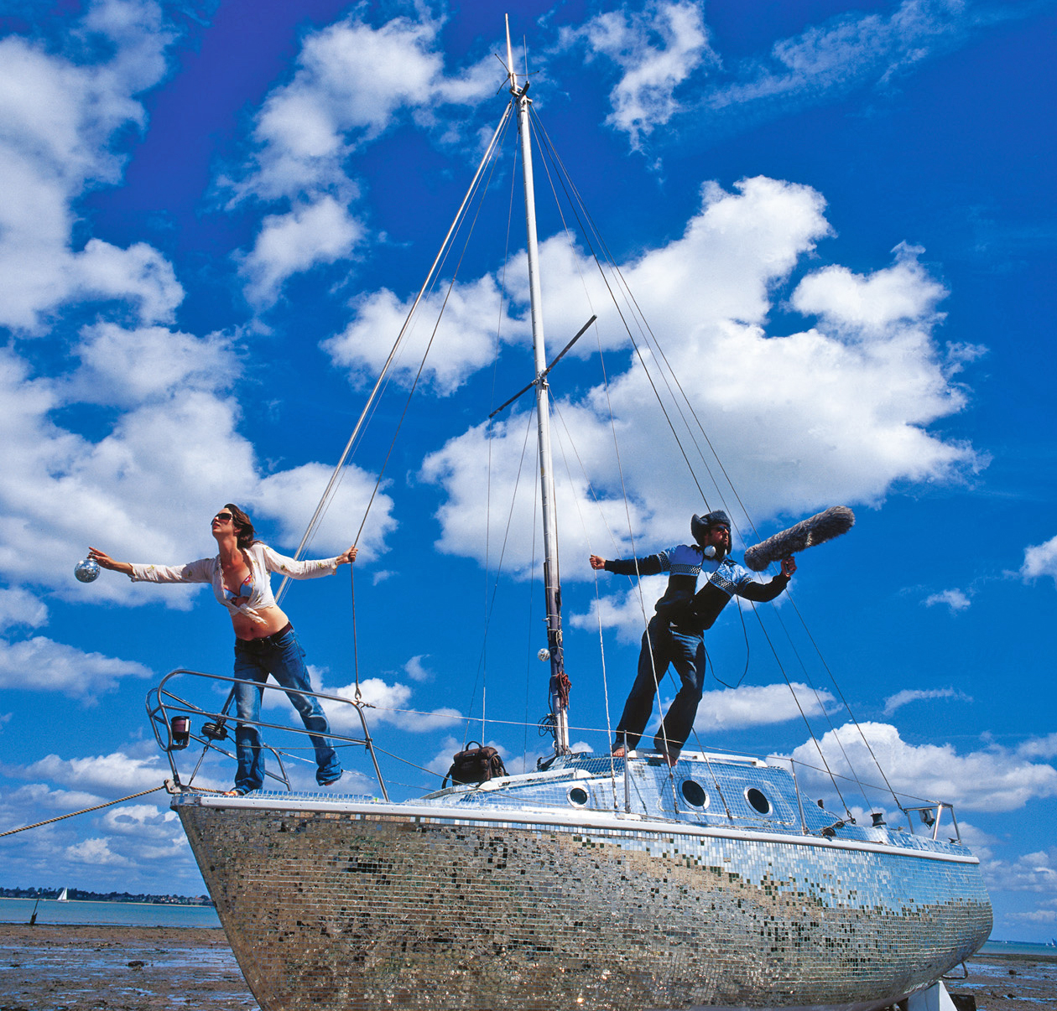
Walker & Bromwich Celestial Radio 2002
Artist Zoe Walker & Neil Bromwich are known internationally for there large scale public events and exhibitions that re-imagine the world around us. Over the last twelve years they have been travelling the world with their project Celestial Radio a mirror tiled sailing boat and radio station.
Join them for a fantastic adventure as they re-discover the lost story of John Bethune of Spinningdale in his quest for lost treasure. We will be making boat shaped hats to wear while searching for treasure, before floating them on Loch Migdale. Come to see if you can make the best boat!
Website - http://www.walkerandbromwich.org.uk

FREE and booking essential. Aged over 7 please. Bring outdoor clothing
Choose one of two sessions: 10.30 – 12.30pm or 1.30 – 3.30pm

To book a place, contact Juliet on
07810 027556 or ledmoremigdale@woodlandtrust.org.uk

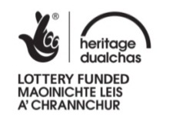


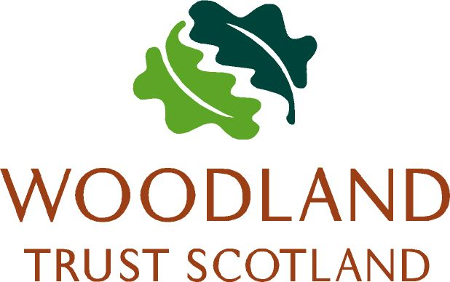
Meet at Torroy car park. From the A949 in Spinningdale, turn onto the minor road sign posted to Migdale. Parking is 0.6 miles on the right (IV24 3AD).

