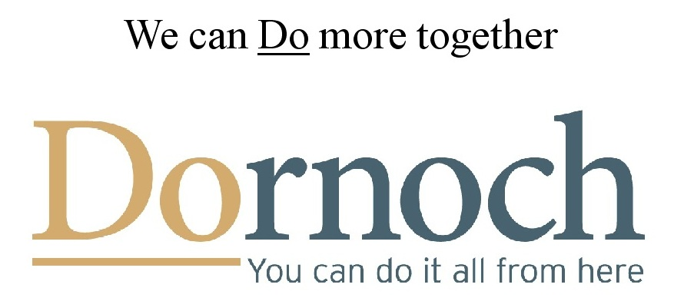

Dornoch Area Community Interest Company

Business Group Meeting

11.09.14
Why do we need a Business Group?
We can do more if we work together. As a group we can engage with bodies like HIE and VisitScotland and benefit from training sessions from Business Gateway and others.
Additionally, we can discuss and take forward new initiatives for Dornoch, share experience and knowledge and aim to benefit each other as well as ourselves.

Tourism in Dornoch
Dornoch is a tourist town – tourism is the biggest industry and a major employer both directly and indirectly.
In thinking about tourism in Dornoch and the surrounding area, we include all visitors from beyond the immediate local area, roughly from Brora to Alness and taking in Lairg to the west, so day trip visitors as well as the holiday makers and golfers and those paying a brief visit such as those on a coach tour.

Together, day and staying visitor spending makes up the visitor economy.

What benefits does tourism bring to our community?
Tourism …
boosts the economy, supporting local businesses and income for local residents;
generates and supports employment;
helps sustain local facilities and services, helping to keep them viable and available for local people to use;
creates positive images, thus encouraging civic pride, creating awareness and helping to make this a great place to visit, live, work and study;
supports a better environment and encourages good environmental stewardship;
pays its way, inducing secondary spending throughout the community, as well as encouraging enterprise and innovation.

How can we maximise the benefit from tourism for our communities?

- By pooling resources to promote Dornoch.
- By working together to plug gaps and reduce the leakage of visitor spending from our area and to ensure we keep as much of the spending by our guests within the local economy;
- By combining our different products and services to create packages for visitors of more things to do that attract new visitors and keep our guests here longer;
- By extending the season;
- By attracting higher spending tourists and, importantly;
- By working together to create a high quality, seamless experience for all our visitors thus increasing visitor satisfaction and encouraging repeat visits.
Coordinating this combined effort, integrating all the different parts of the tourist experience and adding value to our individual efforts could be possible within the Business Group.

What could DACIC’s Business Group do?

- encourage networking and collaboration to create new products to take to the market, thus keeping the destination fresh and competitive;
- provide effective and efficient collaborative marketing benefiting the whole area;
- undertake destination marketing and promotional work;
- facilitate working together to grow tourism and tackle common problems;
- attract and promote signature events for the destination;
- provide training and tourism business support services;
- secure significant additional funding from outside bodies, sponsors and other partners;

Why should we work together?

The short answer is that other, successful groups are already working together and achieving success as a result. Groups like Visit Arran, Visit Cairngorm and others are working to promote their areas and get ahead of the competition. We don’t want to be left behind.
.
How will we know if this is working?

By setting up an agreed evaluation system to measure levels of business, staff employed and business confidence over the year, we will be able to monitor the effectiveness of our initiatives.

By setting up agreed measurable targets, we will know the goals we are aiming for. This will have an impact on tourism growth and will be relevant throughout the community. We will hold regular meetings to report and review progress.

What’s in it for me?

- Use of the new Dornoch logo will be available for all participating businesses subject to adherence to our guidelines.
- More business. By effectively promoting Dornoch to a target audience as a destination of choice, we will bring more people here. It doesn’t matter if you let a single holiday cottage, run a retail business or a B&B, your marketing budget can go further and achieve much more, if just a small part of it goes into the common pool.
- A chance to influence how Dornoch develops. Get involved and have your say.
- Access to workshops and training sessions on topics like marketing and social media.
- Access to subsidised World Host training.

What is the cost?

In setting contribution levels, we’ve consulted similar groups and then taken into account local conditions.

An annual marketing spend of around 2% of turnover is considered normal so this has been taken into account and benefits have also been factored in.

Costs are structured to be fair to businesses of all sizes and are based on trust.

Entry level is set at just £60 for a small business with just one self catering unit and a turnover of less than £30,000 per annum. This is based on the current cost of £30 for an advert on visitdornoch.com plus a contribution of just £30 to the Business Group. An extra booking for even a few days would easily cover this charge.

The next level is £85 for any small business with a turnover of less than £30,000 and the benefits are a website advert and inclusion on the new town map.

For all businesses whose turnover is in excess of £30,000, a contribution of 0.3% is recommended. This would leave 1.7% of the marketing budget available. Benefits, as above are included.

All businesses may use the Dornoch logo* and be part of a Dornoch advertising campaign and will have access to subsidised World Host Training and additional free or low cost training

Your business | Benefit + group membership * | Cost per annum
Single self catering unit, turnover less than £30,000 per annum | Ad on visitdornoch.com | £60 + VAT
Small business, including B&B, turnover less than £30,000 pa | Ad on visitdornoch.com, inclusion on new map | £85 + VAT
Any business with turnover of more than £30,000 pa | Ad on visitdornoch.com, inclusion on new map | 0.3% of turnover, e.g. turnover £75, 000 = £225, turnover of £350,000 = £1050 etc. + VAT

* If DACIC is able to secure funding for the new Dornoch app, businesses included in the new map will also be included in the app.

** The Dornoch logo will be made available to all participating Business Group members at no additional charge. Usage must adhere to the guidelines. Advice on usage will be available from DACIC’s Marketing sub-committee.

How Do I sign up?
Complete this form and send to Joan Bishop, DACIC, Wester Whinhill, Dornoch by September 30th or confirm your interest by email to joan.bishop@outlook.com.
Invoices will be issued in December 2014.

Your name

Business Name

Address

Phone

Email

Payment contribution

