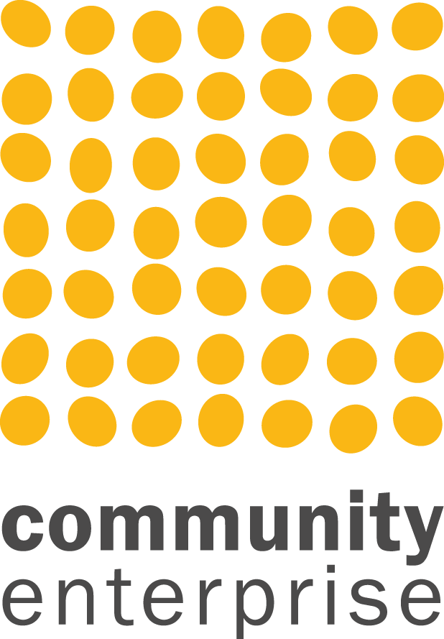

Branding Competition – Brand for Growth

Press Release

To succeed and thrive, social enterprises must communicate well, evidence their worth and compete for business in a busy and innovative marketplace. Investment in a strong and well thought out brand should be core to ongoing sustainability and growth but too often, social enterprises struggle to develop the kind of brand that will set the course of future success.

Brand for Growth is an opportunity to invest in your brand. Funded by the Scottish Government as part of the 3 year Social Enterprise Action Plan ‘Building a Sustainable Social Enterprise Sector,’ Brand for Growth is a competitive programme aimed at ambitious social enterprises with high impact potential who can bring something to the table themselves. The programme is being delivered by BOLD, part of the Community Enterprise family. Some previous examples can be seen at <https://www.bold-studio.co.uk/brand-for-growth-2019-20>

Applicants need to set out how a strong and strategic brand would impact on their business and how it would build capacity. To apply please complete a call for proposals which can be downloaded here <https://www.bold-studio.co.uk/brand-for-growth-2019-20>

and email completed proposals to maria@communityenterprise.co.uk

Deadline: 9am on the 7th October 2019

*Notes:*

**Community Enterprise**

Community Enterprise is a 30 year old, completely independent national social enterprise and third sector support agency. We help to develop enterprise, communities and organisations including strategic thinking, market research, business planning, evaluations, organisational reviews, planning and financing.

**BOLD**

BOLD is a branding, design and digital agency with specialist expertise in social enterprise the voluntary sector. We are a small agency with high standards and a social conscience providing branding strategy, great design and forward thinking websites.

Our activity is focused on achieving our client’s objectives. Our team of committed design professionals provides consistently excellent outputs through our proven process models and our guiding mantra: ’Be Creative, Be Focused, Be Bold'. BOLD is a trading division of Community Enterprise - a social enterprise consultancy with over 30 years’ experience and an track record for knowledge and innovation.